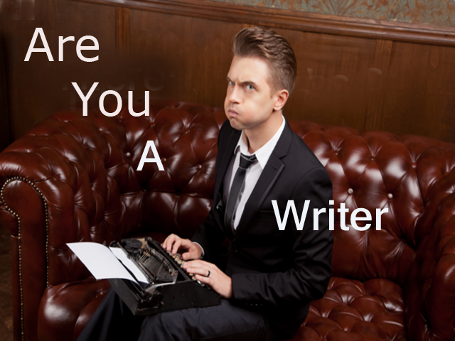

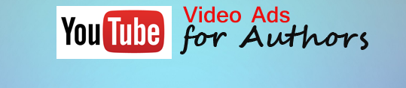
who wants to be an Author?
Or are you already there?
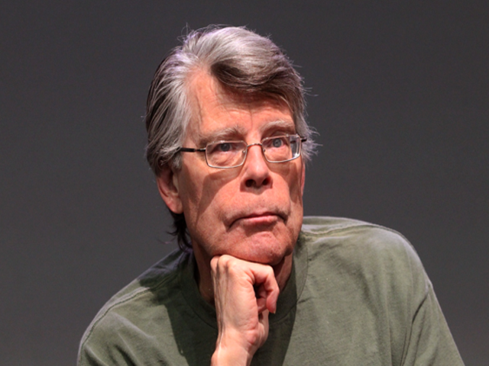
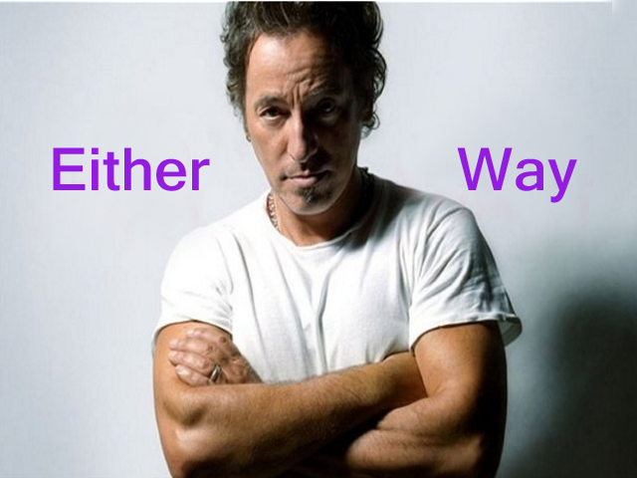

I've got something that will help you take your game to the next level. (Notice I didn't say "WILL TAKE" your game. That's up to you.)
But what I have for you today will definitely help.
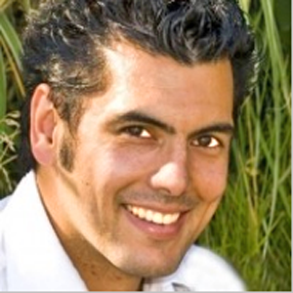
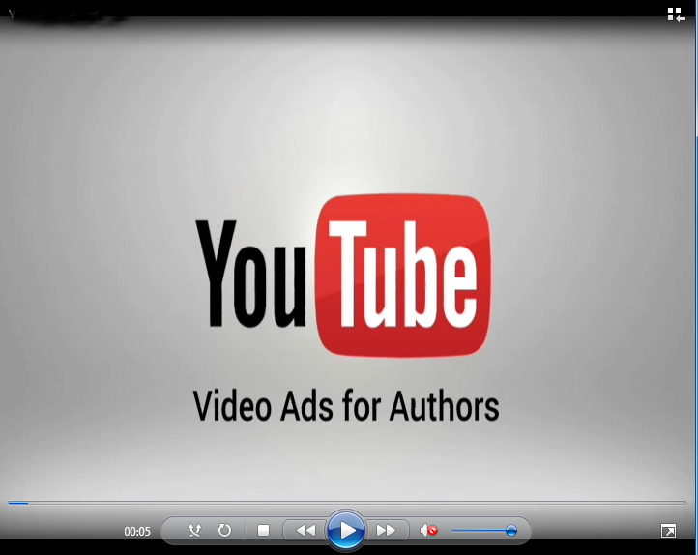
Hi , Tom Morgan, Literary Agent, Author and Publisher here. And I've created the first complete YouTube Video Ads Training SPECIFICALLY for Authors.
But before I show you under the hood - let me answer the obvious question: "Why YouTube Video Ads and not Facebook?''
Simple answer - a five letter word starting with "M" and ending with Y."
With a Facebook Video ad - you're charged after 3 seconds of viewing.
With a You Tube Video ad - if the viewer bails out BEFORE 30 seconds -
YOU PAY NOTHING!
No brainer - right?
Now - inside this A-Z no fluff, nugget packed video training you'll learn:
*The two types of You Tube Video ads and how/when to use them
*How to set up and optimize your YouTube channel.
*How to ''harvest'' relevant keywords from other videos.
*How to navigate Google adwords(where YouTube video ads live) and connect your YouTube channel to it.
*How to set up your first campaign (Plus – why using all the demographic options can be a bad idea.)
(In Video 8 ) How I got one cent clicks for two high competition keywords (''Christmas'' + “Christmas Gifts”) the week BEFORE Christmas.
*How to create your video ad for free (NOT re-using other peoples YouTube vids.) Plus - how to find FREE professional quality images to use in that video.
*How to optimize your video file for maximim YouTube/Google love.
That's it! No OTO. No Upsell/Downsell/Crosssell. No B.S. Just 10 solid, no fluff videos of actionable content.

Here's what two of Publishing's most respected multi-book Authors and content creators have to say:
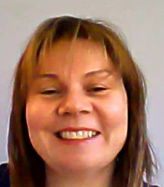
"This is a powerful and much needed training that will help Authors leverage the massive popularity of YouTube to sell more books."
- Amy Harrop -
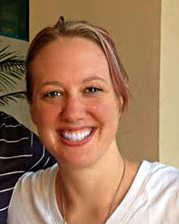
"This is a great step by step breakdown of YouTube ads! Every author should be doing YouTube ads because you can find highly targeted folks to connect with." - Debbie Drum -

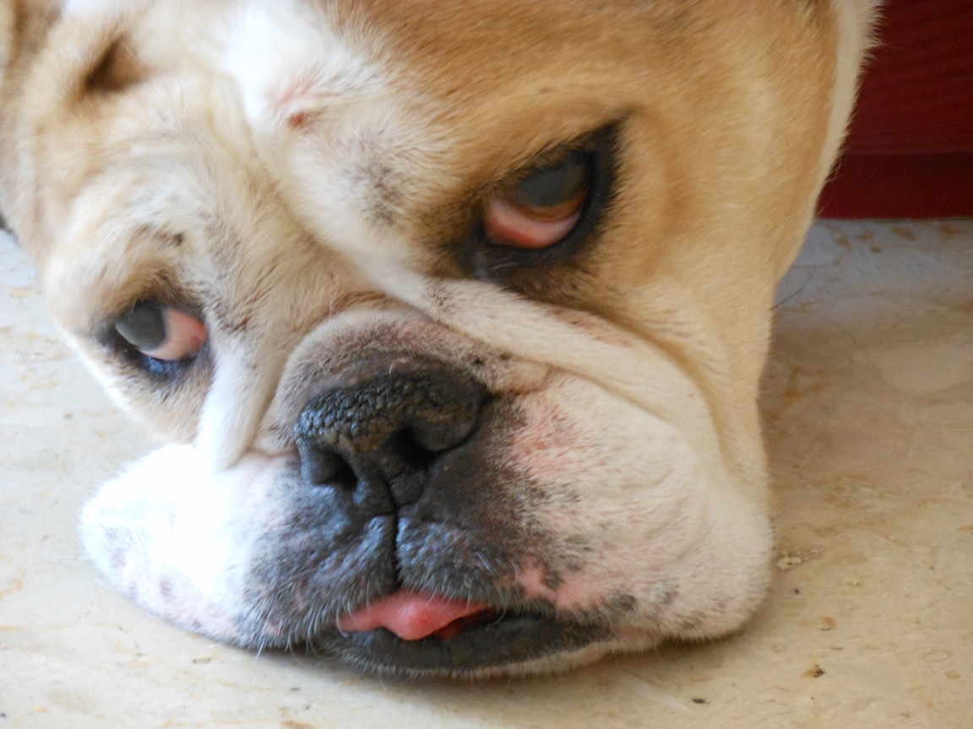
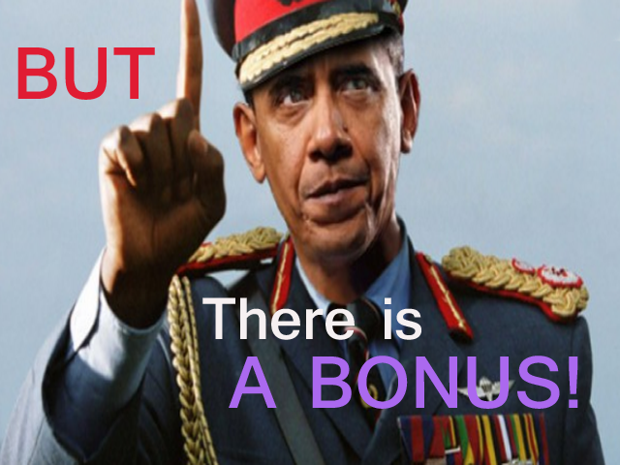
There are NO REFUNDS. For the obvious reason there is nothing to ''like''/''not like.'' It's information. You want it or you don't. No brainer.
The first 20 Writers/Authors who see the incredible value here – will get a 30 minute Skype consultation with me. Any and all questions related to writing and publishing are on the table.
DISCLAIMER: This is a Video tutorial series. Not a ''system.'' I don't guarantee,promise or imply that the information here will translate into book sales. That's up to you. (As is everything in life.)
How much? Now - $27. 6 days from now – $47. Your serve.
Wishing you the best in Literature and Life!
Tom.

BUY NOW

